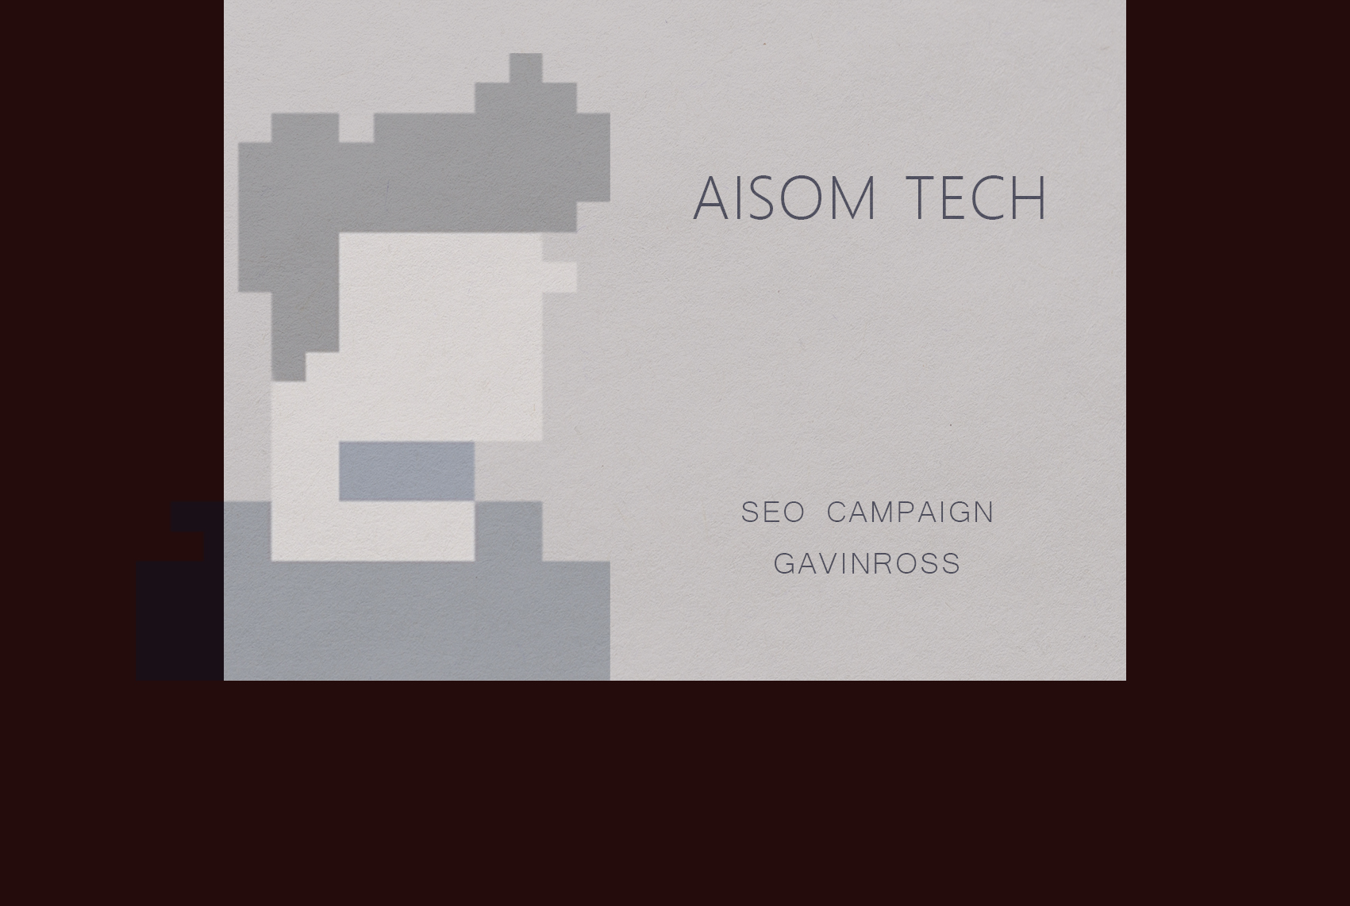

**SE O Ca m p a i g n**

**Cli n to n I nsti tut e**



ABOUT US

We Are Aisom Tech

Aisom Tech is a boutique IT service provider based in Melbourne. Our team of in-house professionals are all equipped with hands-on technical knowledge and industry experience of Search Engine Optimisation (SEO) and other IT product development, allowing them to provide accurate and informative information.

Our SEO specialists do in-depth industry research before working on the optimization of your website to maximise the competitive advantages of your online campaigns when compared to competitors

INDUSTRY EXPERIENCE

We Work With

logo

ABOUT US

Our Team



**FRANK ZHI**

Business Analyst

Frank is a pioneer in various aspects of Business Analytics, and has proven results in delivering strategic outcomes from both a technology and business value perspective.

His strong background in business and data analysis provides a great foundation in building blueprints to help organisations achieve their business goals.

He values collaboration with honesty and relationships with technology partners as a talent leader in Agile IT projects.

DYNAMIC SEO

Our Strategy

SEO

* meta tags
* keywords in content
* URL structure
* sitemaps
* robots.txt
* page-rank sculpting
* more on-site optimisations
* Google Adwords
* E-book marketing
* search engine submissions
* link baiting
* video marketing
* available on local listings
* article submissions



**Off-site**

your-website.com.au

**On-site**

your-websit.com.au

website.com.au



**On-site SEO** refers to the changes that can be done to your website itself. There are numbers of subtle, but highly important changes we make, which often don’t affect the actual appearance of the website, but are “behind the scenes” are noticed by search engines.

Although important, the on-site SEO is only a small part of a comprehensive and effective strategy.

Any existing website content (text or images visible to users) may be optimised by us, and content *may* be added to a particular page to improve user experience.

**Off-site SEO** is engaged particularly if your website is in a high competition market. It refers to other websites, anywhere in the world, that link to your website. These “backlinks” or simply “links” can be in the form of clickable text or images, that navigate a user from one website to your website when clicked.

Any link toyour website is viewed by Google as a ‘thumbs up’- a vote of popularity and trust. Google does not care if links are actually clicked by humans, it only needs to know that links to your website actually exist. Off-site SEO also refers to Social Media signals, business directories and more.

TECHNOLOGY SUPPORT



OUR ALLIES

OPTIMISE CAMPAIGN

Keywords

When it comes to keyword strategy there are numbers of factors to consider. We select a list of keywords aiming provide accurate and effective suggestions. The main goal is to increase targeted traffic through search engines.

The 18 keywords picked is based on a careful analysis by the SEO strategy specialist, competitors, targeted searches, Google Adwords raw data analysis and conversion rate optimisation.

OUR COMMITMENT

Deliverables

* Website & Competitor Analysis
* Keyword Research & Analysis
* Make SEO Friendly URL Structure
* Internal Link navigation
* Unique Titles Tags
* Unique Description Tags
* H Tags Optimization
* Use SEO Friendly Code
* Images and Alt tag
* Xml Sitemaps Creation
* Sitemap Submit in Google Webmaster Tool
* Conversion friendly recommendations
* Google Analytics Install & monitoring
* Keywords density Set
* Resource page Writing
* FaceBook Profile Creation & Maintain
* Directory Submissions
* Social Bookmarking
* Classified Ads Submissions
* Blog Commenting
* Linking to Quality and Relevant Blogs & Websites
* Monthly Progress and Rank Report
* Account manager as one point of contact
* Monitoring Analytics

ESTIMATED

Timeframe

Quoting timeframes for when any particular keyword will rank is very difficult. Although we have methods to control the Google algorithm, there are many variables such beyond our control, such as the level of competition for a particular search term or industry and any new Google system changes that may occur along the way.

Generally, we forecast that:

* + - * Within 60-90 days, there should be significant improvement in rankings
      * Within 4 months, there should be rankings in the top 10 positions for Google desktop, Google maps and Google mobile.

SEARCH ENGINE OPTIMISATION

Pricing

|  |  |
| --- | --- |
| CONSIDERATION | PRICE (ex GST) |
| SEO + Google Adwards Mantenance Package (Australia Wide) | $1500 per month |

* Month by month agreement (30 days notice for cancellations)
* This pricing of $1500+GST per month is for a Australia wide campaign (excludes Sydney)